Syntaxes errors

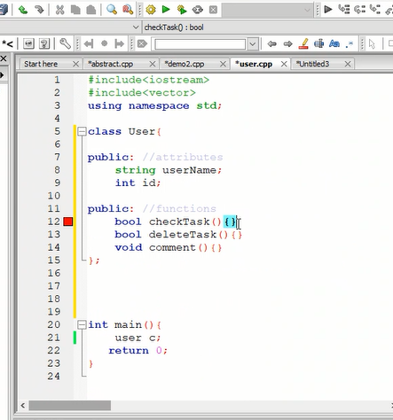

Task id, deadline, upload, delete

In file you can attach file

